**Program 3**

**Creating a View - formatting charts , adding filters , creating calculated fields and defining parameters.**

**Step 1: Connect to Data .**

1. Open Tableau Desktop.2

2. Connect to Your Data Source:

a. Click on Connect on the left sidebar.

b. Choose your data source by selecting text file and load your vgsales dataset into Tableau.

**Step 2:** **Create a Basic Visualization .**

1. Create a New Worksheet:

a. Click on the Sheet tab at the bottom of the screen.

2. Drag Fields to Shelves:

d. Drag Year to the Columns shelf.

c. Drag Global Sales to the Rows shelf.

d. Drag EU Sales to the Rows shelf.

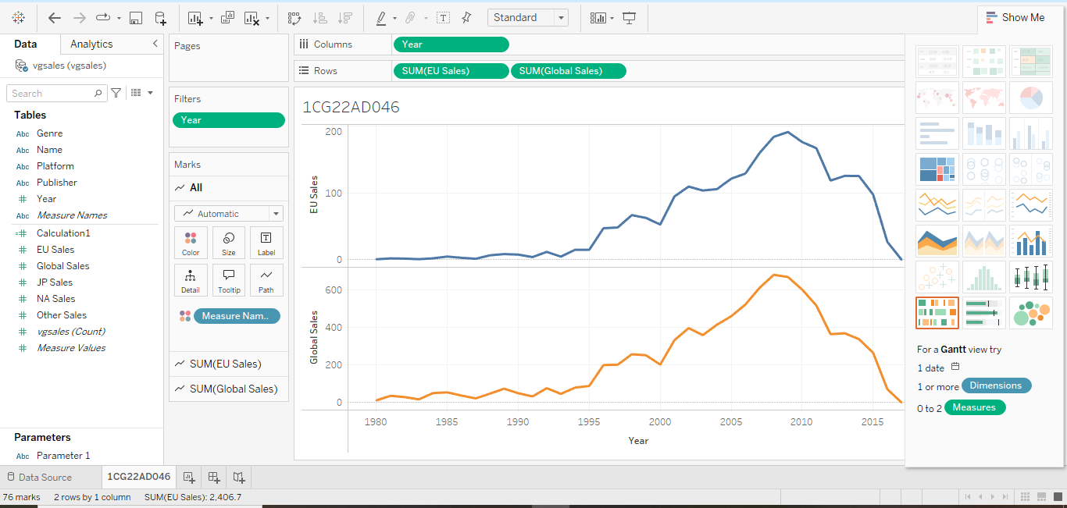

3. Connect to Your Data Source:

a. Click on Connect on the left sidebar.

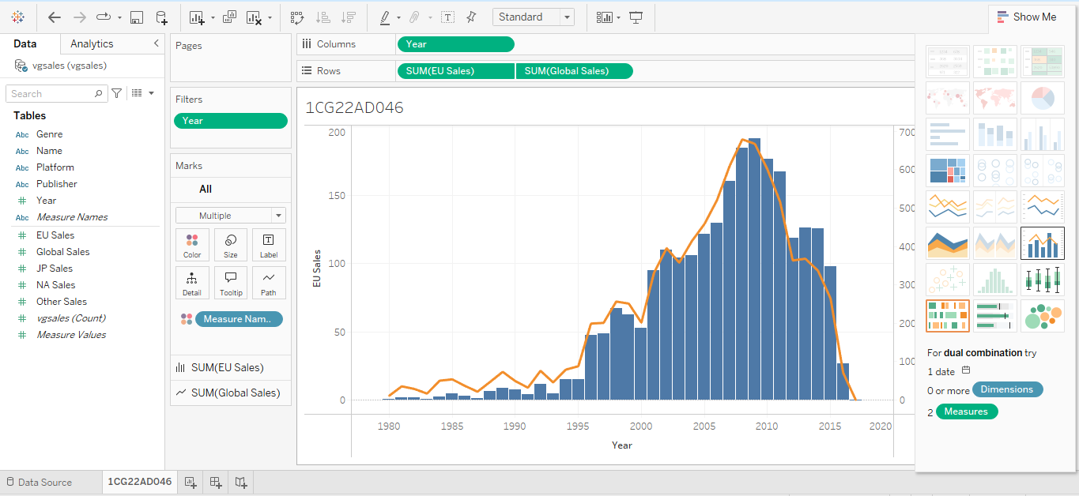

**Step 3: Format the Chart .**

1.Format Axes:

a. Right-click on the Global Sales axis and select Format.

b. In the Format pane, adjust the font style & size as needed.

2.Add Titles and Annotations:

a. Click on the chart title area and enter a descriptive title - Global Sales by Year.

b. Add annotations if needed to highlight specific data points – Right click theon the chart

which you want to highlight - Select Annotate - Select Mark - Press Ok .

**Step 4: Add Filters .**

Add a Filter for Year:Drag Year to the Filters shelf. Choose the range of years you want to display (e.g., 2000-2016).

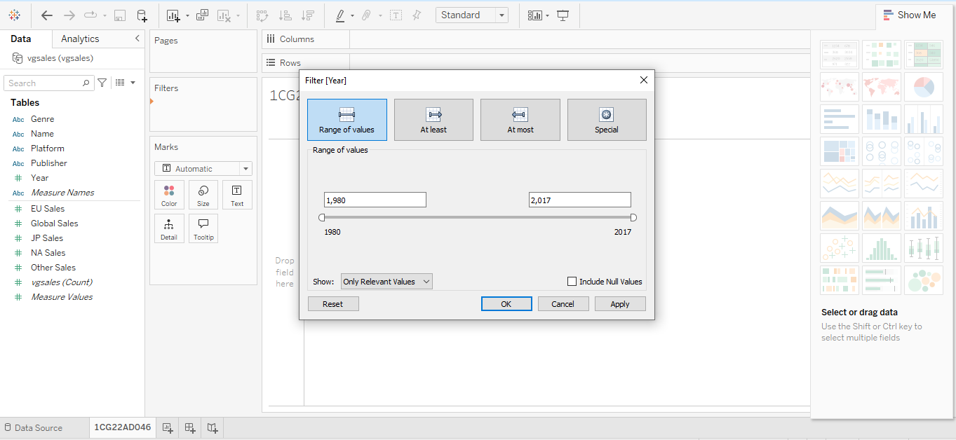

**Step 5: Create Calculated Fields .**

**1. Create a Calculated Field for Sales Category:**

a. Right-click on Global Sales - Select Create - Calculated Field.

b. Give name to your calculations as Global Sales - EU Sales .

c. Do calculations as per your need - [Global Sales] - [EU Sales] .

d. Press Ok.

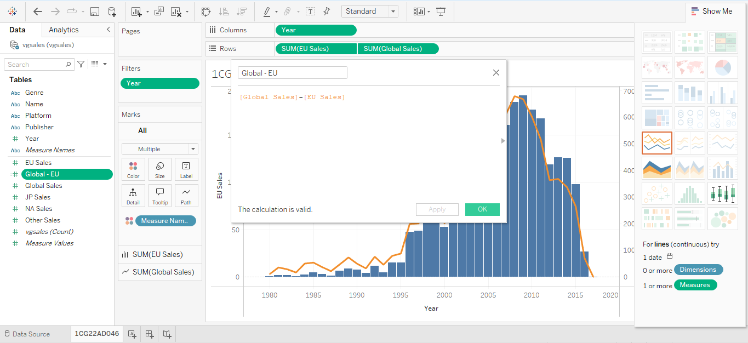

**2. Add Calculated Fields to Visualization:**

a) Drag Global Sales-EU Sales to the Rows shelf to show Global Sales over Yearwith

GlobalSales-EU Sales over Year

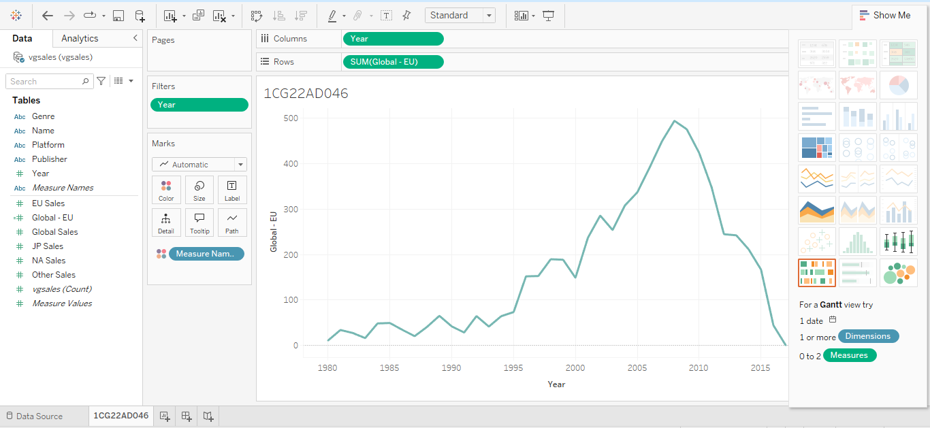.

**Step 6: Create a Parameter:**

Name: "Select Genre"

* Data Type: String
* Values: List (e.g., "Action", "Adventure", "Shooter") or Add values from Genre.

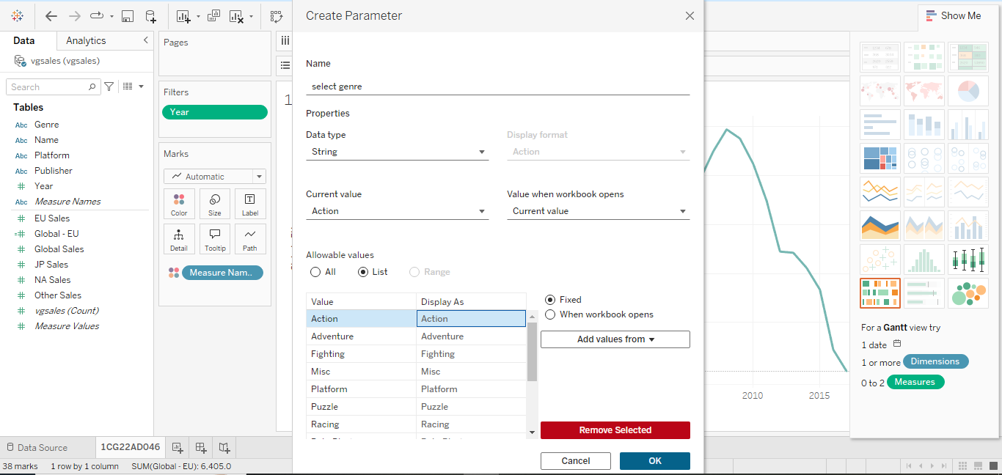

**Create a Calculated Field:**

* Name: "Sales by Genre"
* Formula:
* IF [Genre] = [Select Genre] THEN [Global Sales] ELSE 0 END

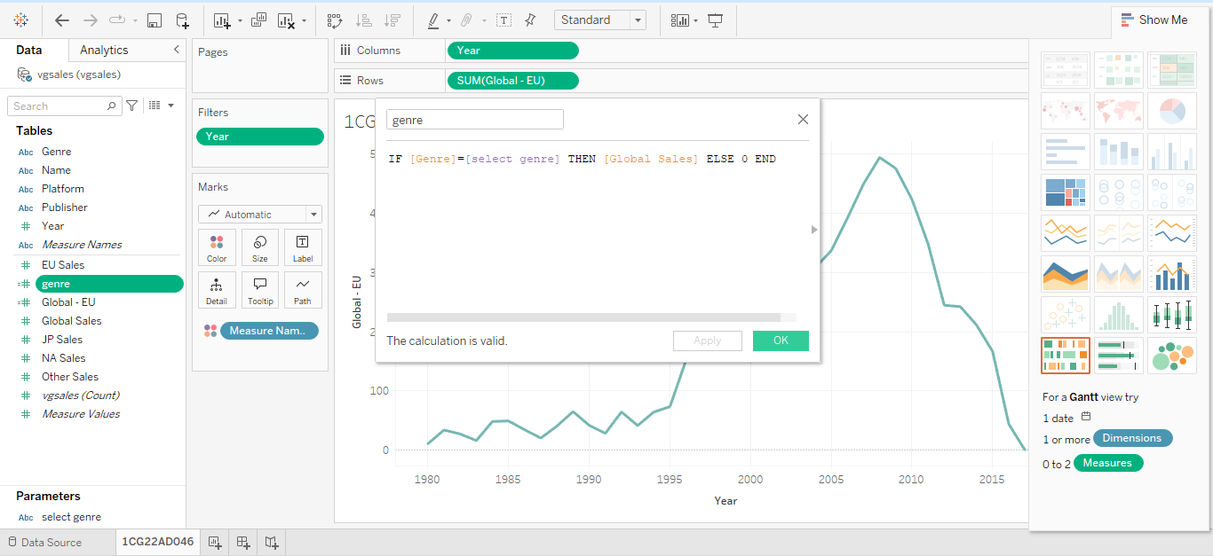

**Build the Visualization:**

* Columns: Drag "Year".
* Rows: Drag "Sales by Genre".
* At the right side of your sheet you can select required Genre andcan see different Visualization - Visualization by Genre: Fighting

**Visualization by Genre: Puzzle**

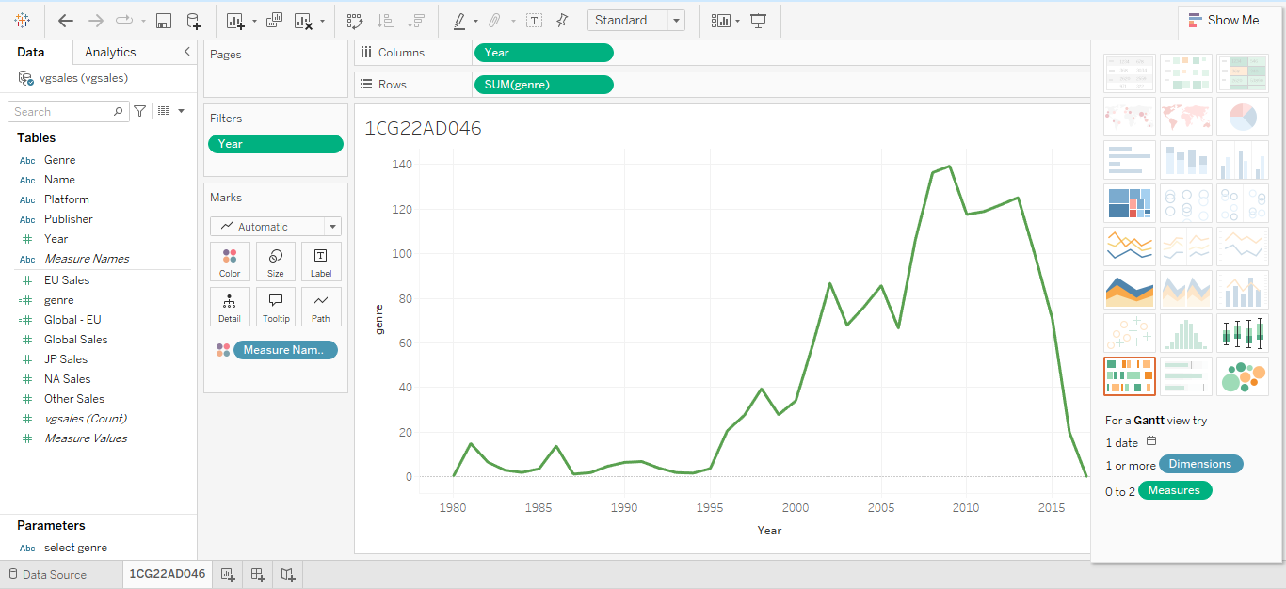

**PROGRAM 4**

**Dashboard Design and Storytelling – Components of Dashboard,**

**Understanding how to place worksheets in Containers, Action filters**

**and its types.**

CREATING A STORY WITH TABLEAU PUBLIC

With Tableau public, you are able to organize your data in order to tell a meaningful story. This is beneficial when you are doing a presentation, creating an article, or uploading to a website, as it helps your audience understand your data. Stories are created through assembling the different worksheets and dashboards. We can highlight important data points, add text box and pictures to help convey our story. However, there are many different ways to tell a story. For example, one technique is called “tailoring in” where the story starts with a big picture view and zooms in on a specific detail. In contrast, a story can also be told by starting with a case and zooming out to that big picture view. We are going to return to our health expenditure worksheets to create a tailoring in story and illustrate the changes in Canada’s spending in a meaningful way.

To begin, select “New Story” at the bottom right of your screen.

**Step 1:**

* **Creating Sheets: Sheet 1**

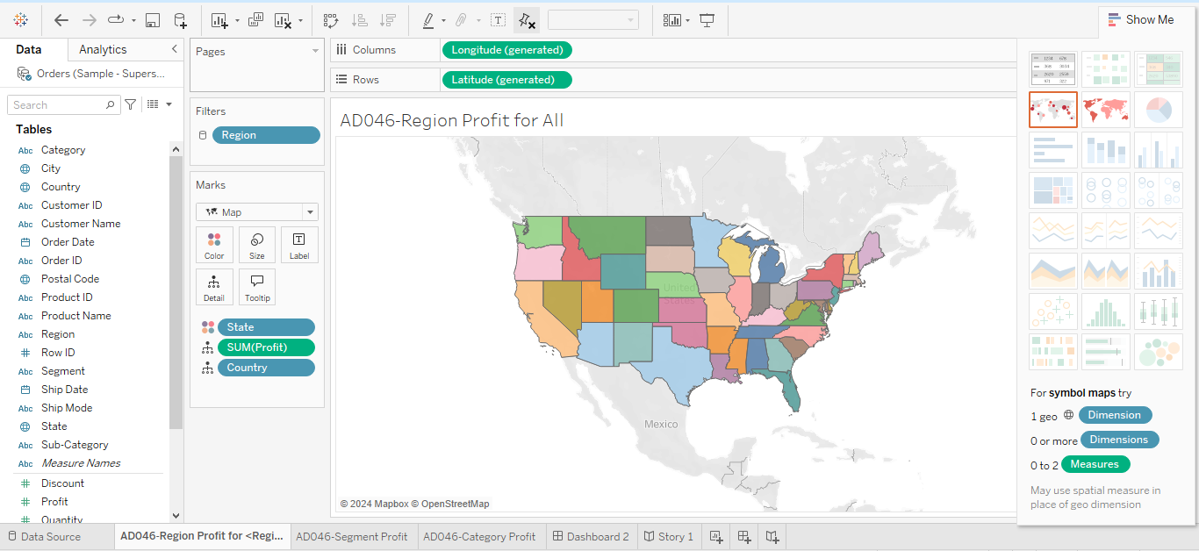

1. Select **“Profit”** and **“State”** and hit **Show Me** select field **Maps**.
2. Right click on Map and select **“Edit Locations”**, **Go to Country/region** select **from field** , we have United States. We selected States because State is Geospatial, and Region is a string variable. If we use Region and Profit , it won’t show map it shows Bar chart.

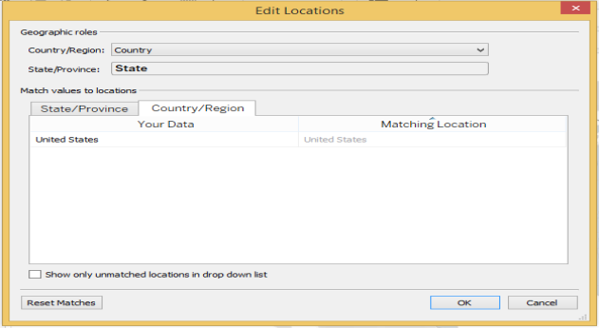

1. Drag and drop **Region** into Filters. Select **Use all** , Click on **Apply** and **Ok.**

Click on Region Dropdown and click on **Show Filter**.

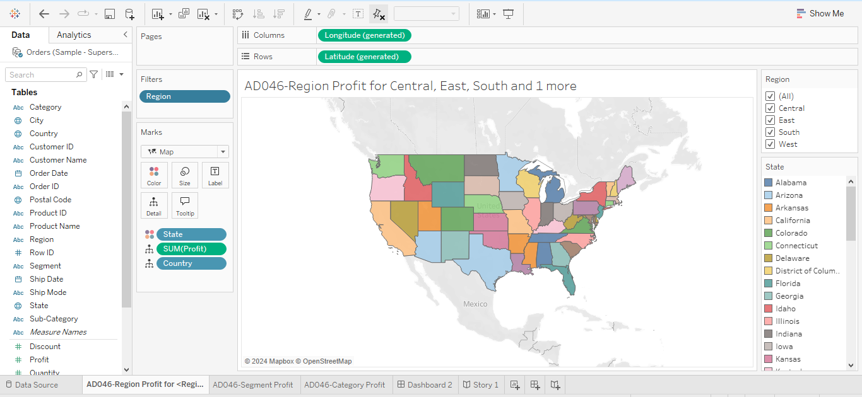

1. Now Rename **Sheet 1** to **Region Profit**

* **Creating Sheets: Sheet 2**

1. Drag and drop **Profit** to Columns and **Segment** to Rows.

2. Select Top and Bottom & Entire View

3. Rename Sheet 2 to **Segment Profit.**

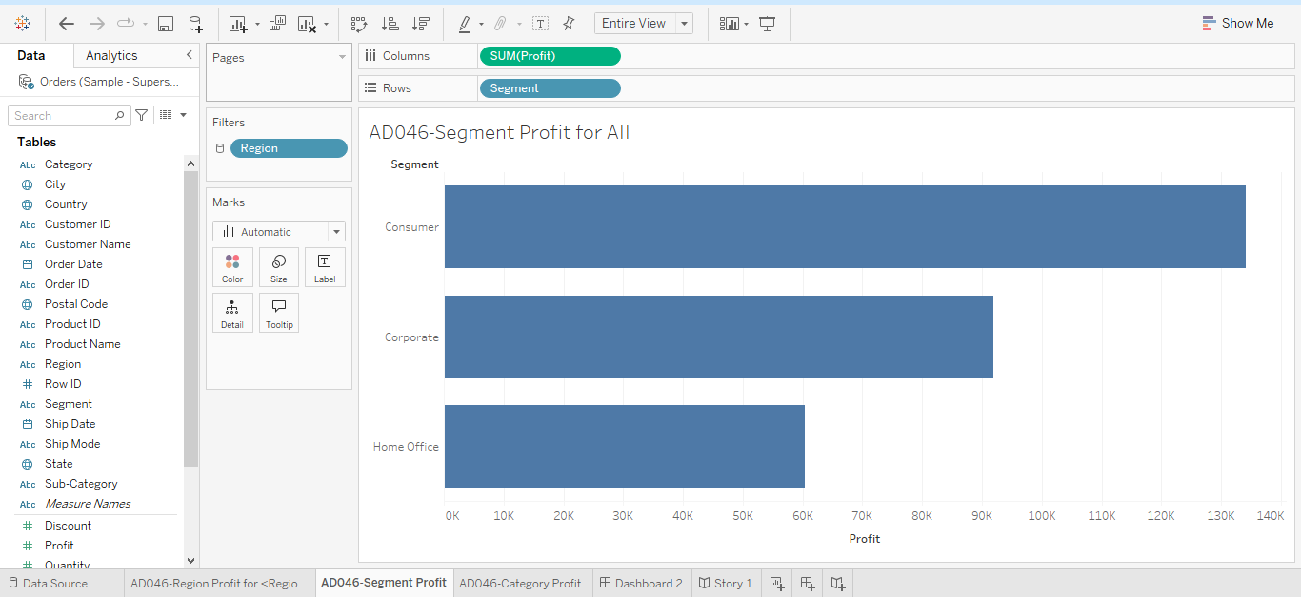

* **Creating Sheets: Sheet 2**

1. Drag and drop **Profit** to Columns and **Category** to Rows.

2. Select Top and Bottom(High to low) & Entire View

3. Rename Sheet 3 to **Category Profit.**

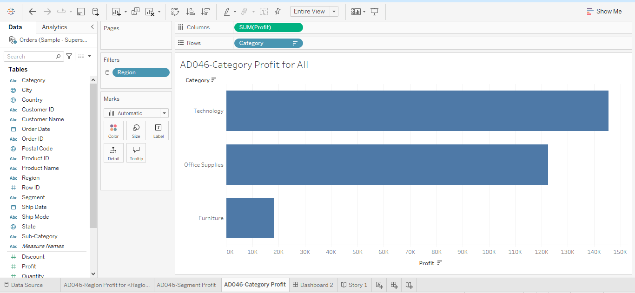

**Step 2: Now get all 3 sheets to Dashboard**

1. **Click on New dashboard, we can see all 3 sheets created in step 1.**
2. Fix view by clicking **Size** and then **Automatic**.
3. Drag **Region** **Profit** first
4. Drag **Segment Profit** below **Region Profit** and then **Category Profit** right next to

**Segment Profit**.

1. Click on more options and click on **Floating.**

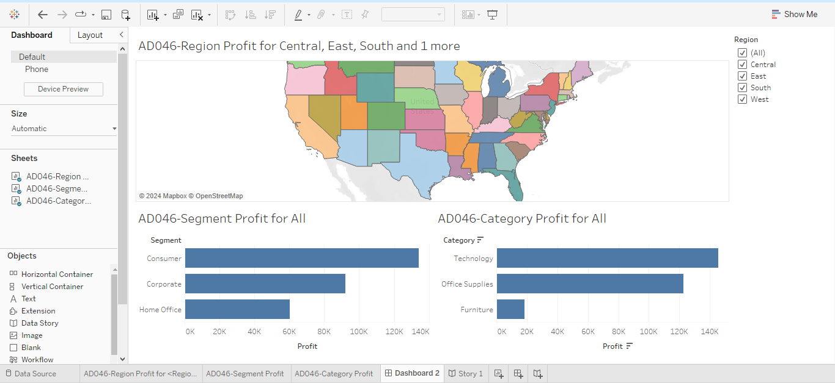

1. When Filtering, Region Profit Filter is working well. But Segment Profit and Category Profit visualization are not moving, they are static.
2. Because Filter option is applied to only Region Profit Sheet
3. To apply Filter option to all the sheets at the same time:

Goto Region Profit Sheet, right click on **Region** Select **Apply** **to** **Worksheets** and then select **All Using This Data Source**.

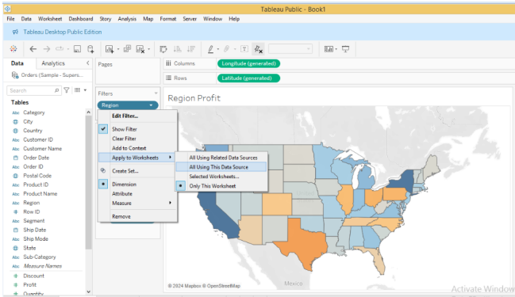

Now we can see Cylinder icon is poped up. This means Filter is used across the worksheets.



Now check Filter option is working in dashboard.

1. To display Region name in Region Profit Title, Double click on region Profit and include

Region.

1. Similarly display Region name in Segment Profit and Category Profit Title

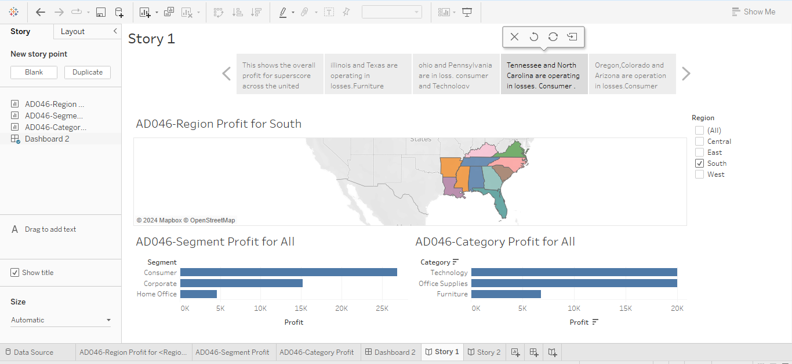

**Step 3: To create Story**

1. We can see 3 Worksheets and 1 Dashboard which we created in step 1 and 2.
2. Fix view by clicking Size and then Automatic, which is at the bottom left.
3. Drag and drop Dashboard 1 into the space.
4. We can only put one visualization at a time. If we add Region Profit automatically dashboard 1 will be replaced by Region Profit Sheet.



1. We can see 2 tabs Story and Layout. In Layout we have Navigation Style

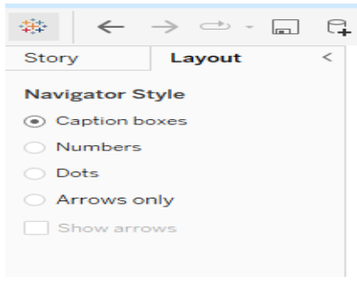

1. Add a Caption to the Story as shown below ***“This shows the overall profit for superscore across the united states.”***

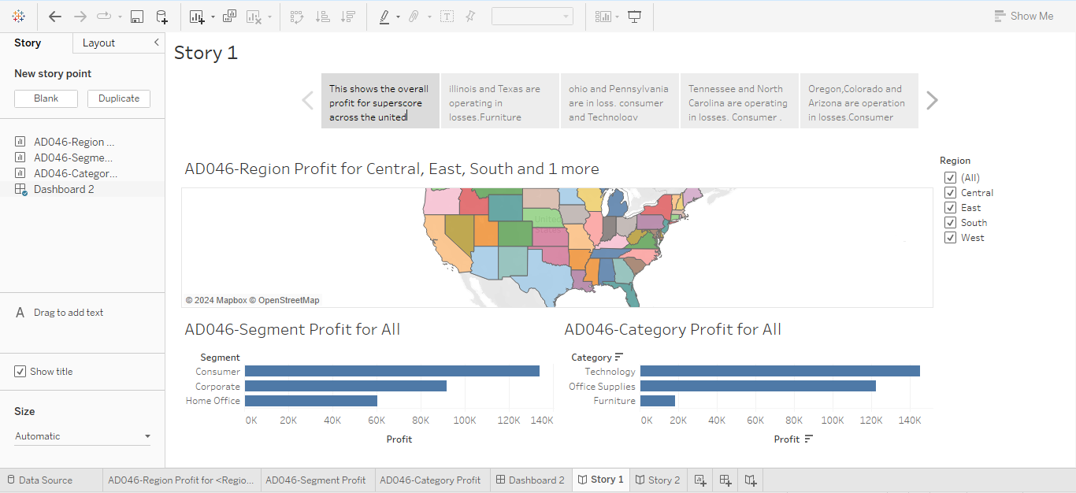

1. To create a next slide or next step in our story, click on **Blank** or **Duplicate**. Now Click on **Blank**, new story board as opened up.

Now drag and drop dashboard again, now we will do Region by Region analysis.

First we choose **Central** **Region**, we can see central region is come up in the map, we can see “Texas and Illinois” are in loss. Furniture category is in loss, Technology and office Supplies are doing well. Let’s add the same in caption ***“Illinois and Texas are operating in losses, Furniture category should be analyzed further.Corporate segment is the most profitable.”***

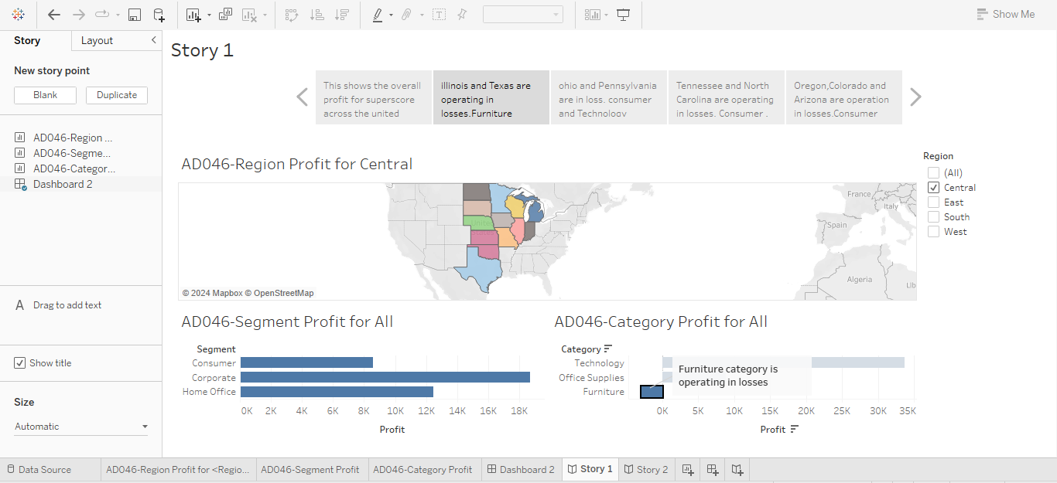

1. Now Duplicate and select East Region. And add a caption ***“Ohio and Pennsylvania are in loss. consumer and Technology segment are more profitable.”***

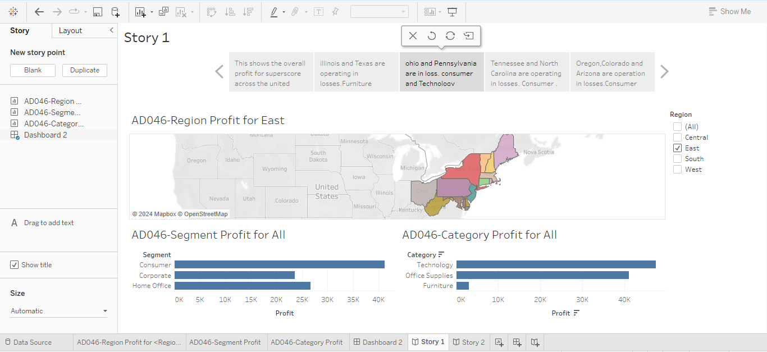

1. Again Duplicate and select South region. Add add a caption ***“Tennessee and North Carolina are operating in losses. Consumer , Technology and Office Supplies segment are in more profitable.”***



1. Again Duplicate and select West region. Add add a caption ***“Oregon,Colorado and Arizona are operation in losses.Consumer and Office supplies segment are in more profitable.”***

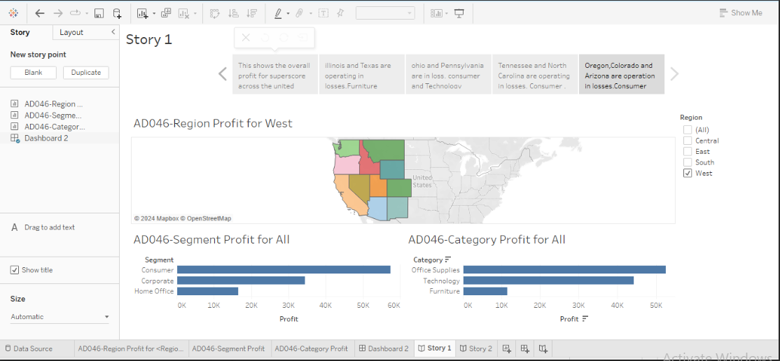

1. To add Annotation feature in story board. Goto Central Profit page ,Right click on

Furniture (which is under loss), Select **Annotate** and then **Mark**.

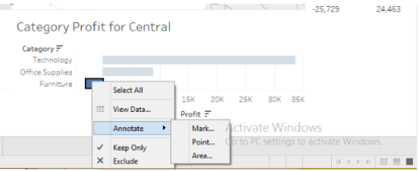

***Add a caption as shown below:***



